**SQL Developer Internship Documentation**

**Data Manipulation**

**Objective**

Enhance skills in SQL by modifying table structures and managing records through adding columns and deleting specific records based on conditions.

**Project Steps:**

**1. Modify Table Structure**

**Add and Populate New Columns:**

* **Action:** Use the ALTER TABLE statement to introduce new columns.

**Example Columns:**

* LastUpdated (DATE) – To record when the row was last modified.
* Status (VARCHAR) – To denote active or inactive records.

**Populate New Columns:**

* Use the UPDATE statement to set initial values or use default values for the new columns.

**Example:** Set Status to "Active" for all existing records.

**Query:**

ALTER TABLE Employees ADD COLUMN LastUpdated DATE;

ALTER TABLE Employees ADD COLUMN Status VARCHAR (10) DEFAULT 'Active';

UPDATE Employees SET LastUpdated = CURRENT_DATE;

UPDATE Employees SET Status = 'Active';

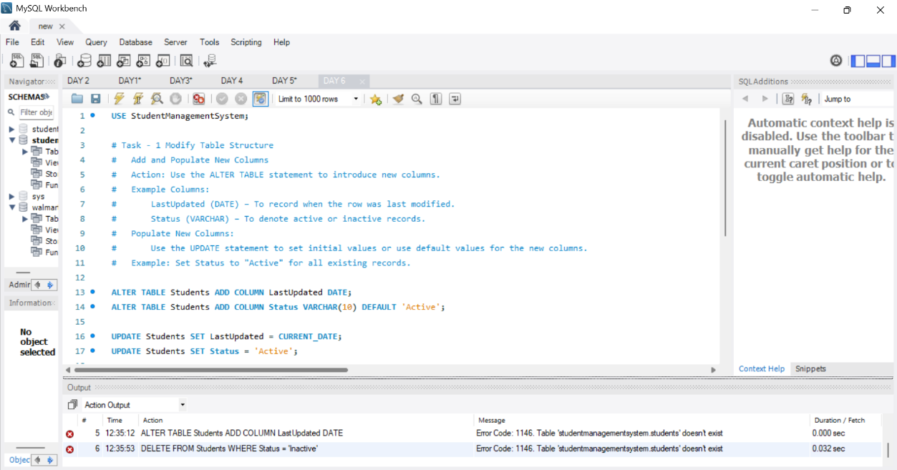

**2. Delete Records Based on Conditions**

**Remove Records Based on Criteria:**

* **Action:** Use the DELETE statement to remove records from the table.

**Example Conditions:**

* Delete records where Status = "Inactive".
* Remove records older than a specific date in the LastUpdated column.

**Confirm Deletions:**

* Query the table to ensure that only the intended records were deleted.
* Optionally, use a SELECT statement with the same condition before deletion to review records.

**Query:**

DELETE FROM Employees WHERE Status = 'Inactive';

DELETE FROM Employees WHERE LastUpdated < '2023-01-01';

SELECT * FROM Employees WHERE Status = 'Inactive';

SELECT * FROM Employees WHERE LastUpdated < '2023-01-01';

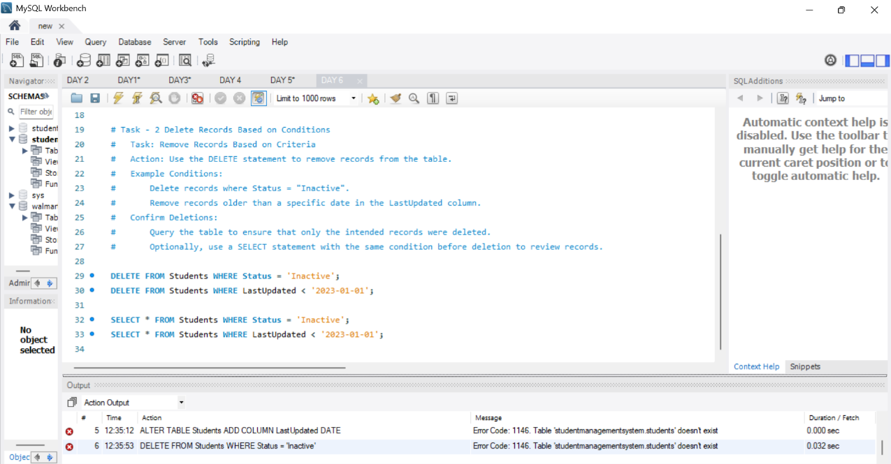

**Summary**

The project involved modifying the table structure by adding new columns and managing records through condition-based deletions. This helped in ensuring data relevancy and tracking modifications more effectively. Key insights were gained from the deletions, particularly in maintaining an active and up-to-date dataset.

**Key Findings:**

* Successfully added LastUpdated and Status columns to enhance data management.
* Populated initial values for Status to ensure consistency.
* Effectively removed inactive and outdated records, reducing data clutter.
* Improved data integrity by validating changes and ensuring accurate deletions.

**Main Flow Services and Technologies Pvt. Ltd.**

* **Contact No.:** +91 9389641586, +91 97736 99074
* **Email:** contact.mainflow@gmail.com
* **Website:** www.mainflow.in